2 | METHODS

2.1. Host-parasite system

The black spot disease is a common fish infection in marine and freshwater ecosystems caused by Digenean trematodes (flukes) (Kurochkin & Biserova, 1996). Despite some of these parasites (e.g., Posthodiplostomum cuticola, Uvulifer ambloplitis, Crassiphiala bulboglossa and Apophallus brevis) have been studied for a few decades, spatiotemporal infection patterns and their relation to environmental conditions are still elusive. Black spot causing trematodes all have a similar complex life cycle requiring a snail, a fish and a piscivorous bird as hosts (Figure 1). The parasite encysts under the skin, in the fins or the muscles of the fish-host (Hoffman, 1956; Krull, 1932, 1934) where it can survive in a dormant form for a few years (Hoffman & Putz, 1965) until the infected fish gets eaten by a bird. The distinctive black cyst symptom results of the melanin pigment stimulation by the larva penetration in the fish body (Davis, 1967; Lemly & Esch, 1984). In the context of this study, we will refer to the black spot trematodes as a guild because they have similar ecological requirements and cause the same symptoms in fishes.

FIGURE 1

The typical lifecycle of a parasite species causing the black spot disease in freshwater fishes. (A) The definitive host is a piscivorous bird, usually a kingfisher or a great blue heron. The metacercariae mature to its adult form and reproduce in the bird digestive system. (B) The eggs are released in the water through the bird feces and grow into miracidia (first larval form). (C) The miracidia infect the first intermediate host, a freshwater snail of Helisoma or Planorbella genus. The larvae develop into free-living stage cercariae (second larval form) and leave the snail. (D) The cercariae swim until they encounter a potential fish host. (E) The second intermediate host is a fish. The cercariae penetrate under the skin or the fins and transform in the metacercaria form. (F) The fish is eaten by a definitive host.

Akin to other parasitic diseases, the infection parameters of the black spot disease can vary across time, space, and species. For example, the infection prevalence in bluegill sunfish (Lepomis macrochirus) inhabiting ponds reaches its minimum around April/May and its maximum around September/October (Lemly & Esch, 1984). The habitat characteristics that favor snails’ requirements such as shallow waters and macrophytes have also been associated with higher infection levels in fish-hosts. Hence, infection levels of the black spot disease in fish-host are usually higher is lentic systems and in the littoral zone rather than the pelagic zone (Ondrackova et al., 2004) because the encounter window is larger in these habitats (the snails and the fish habitats overlap). Since the black spot disease is caused by a parasite guild, a large range of fish species can be infected. However, some species tend to be more heavily infected than others. For instance, Lemly & Esch (1984) found that bluegill sunfish were more heavily infected than largemouth bass (Micropterus salmoides).

2.2. Study area

We sampled 15 lakes from six watersheds in Saint-Hippolyte, QC, Canada (Figure 2). The lakes Corriveau, Croche, Cromwell and Triton are in the protected area of the biology station of the Université de Montréal while the other lakes are surrounded by private properties. Considering their geographical proximity, we assumed that all the lakes are exposed to the same climatic conditions. The lakes were selected nonrandomly according to the accessibility and the availability of morphometric data (see Table S1 for the morphometric characteristics).

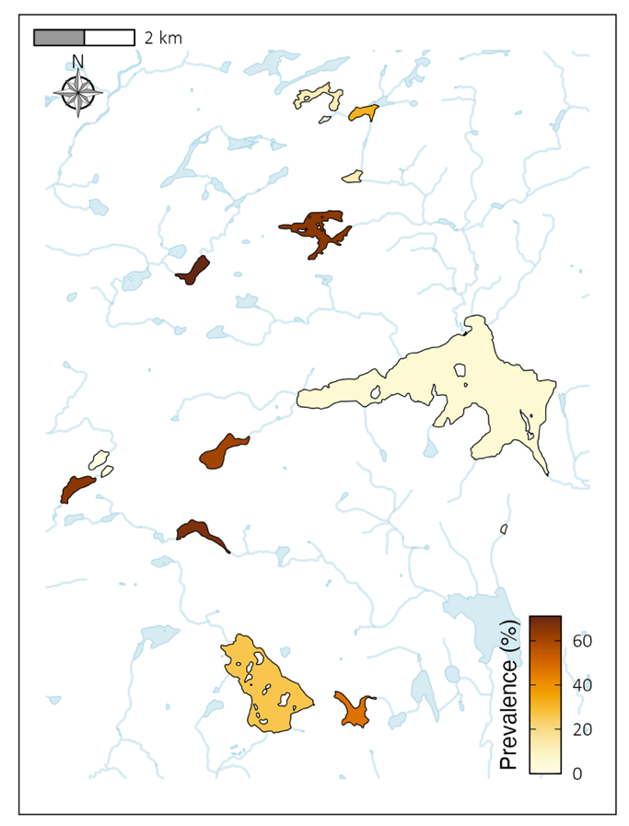

FIGURE 2

Map of the study area. The lakes sampled are colored according to the black spot disease infection prevalence of the local fish community in the littoral zone of the lake. The data used to estimate the infection prevalence comes from all the sampling methods combined.

2.3. Data acquisition
Three sampling methods (minnow traps, seine nets and transects) were used to assess prevalence infection and maximize the chances of catching different fish species. The field work took place from mid-June to end of August 2022 and was restricted to unrainy days to limit sampling bias due to meteorological effects. Animal handling was approved by the Université de Montréal’s animal care committee (protocol number 22-025) and scientific fishing permit was delivered by the Ministère des Forêts, de la Faune et des Parcs (MFFP) of Québec (2022-05-16-1971-15-S-P).
Sampling effort within lakes was established according to the lake area, except for minnow traps (see Table S2) as it requires less time and manipulations than the other methods. Seine sampling varied between four and eight efforts while the number of transect sites varied between two and six per lake. 15 minnow traps were set in each lake to maximize the number of captures.
The minnow trap and seine net samplings were both conducted on the same day for each lake. The seine samplings occurred during daytime in habitats lacking big obstacles like trunks and large rocks in which the net can get stuck. Two sizes of minnow traps were set at approximately equal distance along the shore, from 4PM to 8PM, to target species that are most active at dusk. There were no habitat restrictions for the minnow trap emplacements. Half of the traps were baited (3 large and 5 small traps) to sample various feeding preferences and behavioral habits. The fishing gear dimensions are available in Table S3. All the fishing gear was cleaned between lakes following MFFP recommendations to prevent exotic species contamination.
All the fishes were counted, identified to the species level, and measured (estimation of the total length to the nearest centimeter) directly after capture and released afterwards. Northern redbelly dace (Chrosomus eos) and finescale dace (Chrosomus neogaeus) individuals were identified as Chrosomus spp. as the two species hybrid in our system and cannot be distinguished based on morphology in the field (Leung et al., 2017). The presence of black cysts was assessed on the fish left side (De Bonville, in prep.). Juveniles and adults were included in this study as all individuals are vulnerable to the black spot disease.
Fifty meters snorkeling transects along the shore were conducted to assess black spot infection prevalence in the fish communities. Due to time constraints, lakes Beaver, Montaubois, Tracy and St-Onge were excluded of the transect sampling because of low fish abundance in the fishing samplings or poor water transparency. We selected sites that were approximately between 0.5 and 3.0 m deep, not fully covered by macrophytes, not obstructed by docks and preferably with some vegetal, rock or trunk refuges for the fishes. The sites were picked and flagged every ten meters at the end-May 2022. The transects were performed by two observers at the time covering each a one-meter radius field of view and moving forward at a pace of three minutes by ten meters. The fishes coming in the field of view from behind the observer were not counted. All the fishes were identified to the lower taxonomic level possible and black spot infection was noted. All cyprinids were grouped into the same category since they are more difficult to identify at the species level and usually move faster.

Following the prevalence transect assessment, we completed the habitat description. The percentage of substrate categories (silt, sand, rock, and metric block), the macrophyte coverage, the number of trunks (or large branch), and the mean depth was estimated for each 10-meter segment. The mean estimation was then assessed for all variables at the transect-scale. Temperature, dissolved oxygen, conductivity and pH were measured at mid-depth at the beginning of every transect with a YSI ProDSS Multi-Parameter Water Quality Meter. 1 L of unfiltered water was taken at mid-depth in previously acid-washed HDPE bottle for carbon and nutrient content analyses. The samples were placed in a dark cooler until brought back to the laboratory where the 1 L samples were separated in previously acid-washed 40 mL vials for total organic carbon (TOC), and 500 mL HDPE bottle for total nitrogen (TN) and total phosphorus (TP). TOC samples were placed in a 4°C refrigerator and analyzed within the week while TN and TP samples were kept in a -20°C freezer until later processing. TOC sample contents were measured on Siervers M5310 C Laboratory Total Organic Carbon Analyzer. TN and TP samples were oxidized with persulfate and put to the autoclave the day before analysis following EPA methods 353.2 and 365.3 respectively (US EPA, 1978, 1993). TN concentrations were measured on a Lachat QuikChem 8500 analyzer and TP concentrations were analyzed on a Asoria-Pacific Astoria2.

2.3. System description

We recorded a total of 11 297 individuals belonging to 15 species for this study (Table S4).
The minnow traps caught 1906 individuals from 10 species while seine nets caught 2427 individuals from 14 species (Table S5 and S6). 6964 individuals belonging to five taxonomic groups (four species and one family) were observed in the snorkeling transects (Table S7). The mean length of all fish captured through fishing methods was 5.59 ± 2.96 cm (N = 4333). The overall mean length of each lake, species and, species within each lake are presented in Table S8, S9 and S10.
In the context of this study, the infection prevalence was estimated as the number of infected individuals by the black spot disease, divided by the total abundance of a given fish community. All fish species in our lake system, except for Ameiurus nebulosus and Esox masquinongy are susceptible to the black spot disease (see Table S11). Based on the data from all the sampling methods, the regional community prevalence is 29.55 %, the local (i.e., lake) prevalence varies between 0% and 70.97% (Table S12) and the fine-scale prevalence (i.e., transects) varies between 0% and 100% (Table S13). Our survey corroborates black spot infection in pumpkinseed sunfish (Lepomis gibbosus), rock bass (Ambloplites rupestris), yellow perch (Perca flavescens), Smallmouth bass (Micropterus dolomieu), creek chub (Semotilus atromaculatus) and fathead minnow (Pimephales promelas).

The results for TN and TP concentrations are presented in Table S14 along with physico-chemistry measurements. The mean habitat descriptions are presented in Table S15 for each transect.

2.4. Statistical analyses

We employed the following procedures to describe the black spot prevalence pattern across multiple scales (landscape, lake and site). All data manipulations and analyses were conducted using R (version 4.2.3). Lake Tracy was excluded from the lake-scale analysis because of low abundance data (N = 1).

For the landscape-scale analysis, we wanted to look at the effect of the sampling design (here sampling method and sampling effort) in the estimation of a landscape prevalence. We used a resampling approach on the data from the different sampling methods (minnow trap, seine net, transect, and all methods combined) to visualize the accumulation of i) the infected individuals, ii) the total individuals and, ii) the infection prevalence, through an increasing sampling gradient. The abundance data (infected and total individuals) from every lake were pooled together, and the prevalence was calculated for every sampling effort (N) as the number of infected divided by the total number of individuals in each sample. Then, we randomly drafted 999 times N samples (N = c(1:35)) of a given category (infected individuals, total individuals or prevalence) for each method. Drafted samples of a given N value were summed for the infected and total individuals simulations while we calculated the weighted mean of the prevalence samples. A local regression was then fitted to the mean estimate of each sampling effort value for visualization of the accumulation curves. For the prevalence simulation, we estimated the final landscape prevalence and the approximate sampling effort needed to reach a steady prevalence value.

For the lake-scale analysis, we examined the frequency distribution of the lakes’ prevalence according to the sampling method. The mean infection prevalence was previously calculated for each lake, and visualization was made with histograms. The distributions were then compared with the map of the study area (Figure 2) for spatial patterns.

For the fine-scale analysis, we modeled the relations between environmental drivers and the community infection prevalence on a transect level. We used the prevalence data from the transect method because it is the only method that allows an accurate association with the habitat description on a fine scale (physical habitat, physico-chemisty parameters and nutrients) thus allowing to understand key drivers of infection hotspot. Prior to analysis, we explored data for outliers in response and explanatory variables, for collinearity between explanatory variables, and for the type of relationships between the response and the explanatory variables following Zuur et al. (2009) recommendations. We decided to keep the outliers in the analysis because we have limited samples, and because it reflects the environmental heterogeneity. Our data showed some non-linear patterns. Consequently, we used generalized additive models in mixed-model framework (GAMMs) fitted using marginal likelihood (ML) estimation to account for spatial clustering of sites from the same lakes. We used a quasi-binomial family distribution because our response variable is a proportion constrained between 0 and 1 and, to account for overdispersion in the data. The optimal amount of smoothing (λ) was internally determined by the modeling function from the mgcv package (Wood, 2017). Since we had a small sample size for the transect method (N = 39), we modeled one environmental variable at the time with a cubic spline and a random effect on the lake variable to save degrees of freedom. The deviance explained (D²) was used as a measure of the model fit. The model validations were conducted with gratia package (Simpson, 2023). The visualization of the partial effects was made with gratia (Simpson, 2023) and ggplot2 (Wickham, 2016) packages.

